Test Case: tc001_SPX_Dev5_Crear_Requisicion_Spot_Tipo_Cobro_CC
Step 1 - Enter username and password and click to button Enter : Credentials Entered
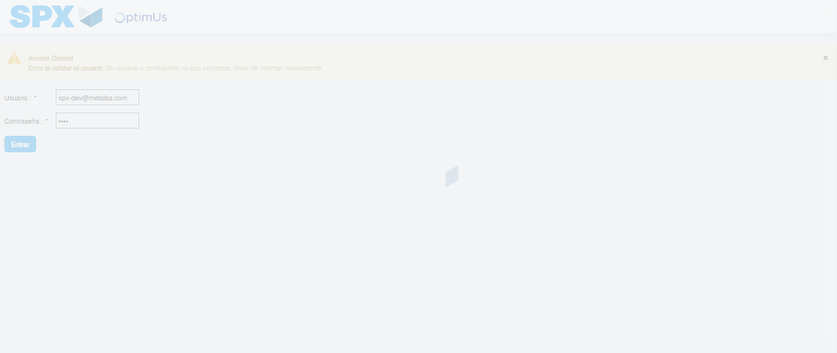Image file-name: QC_Testing-tc001_SPX_Dev5_Crear_Requisicion_Spot_Tipo_Cobro_CC-1782164004149

Step 2 - Select to UEN and Access to Spot Buy Requisitions : UEN Correctly selected and Correct access
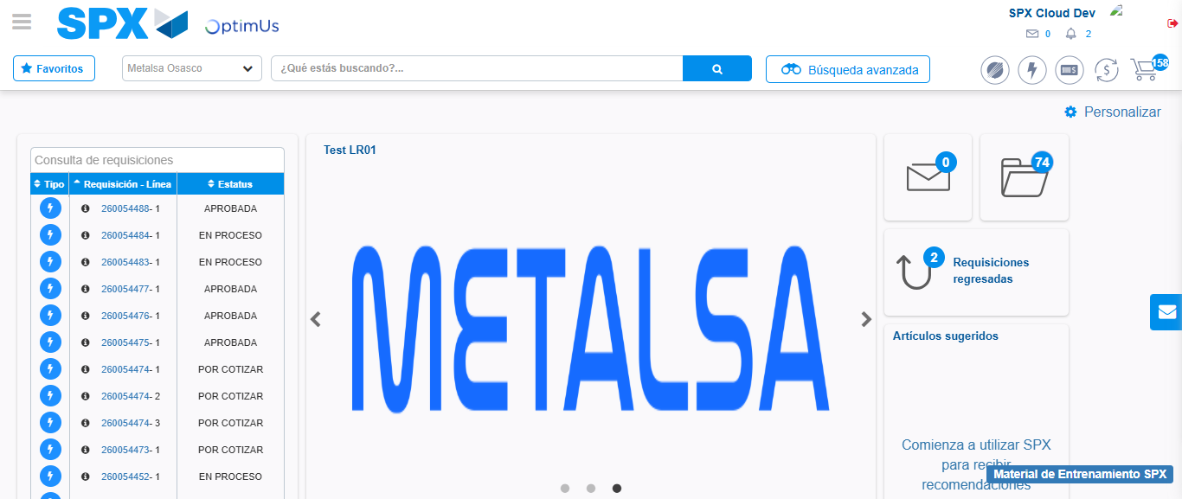Image file-name: QC_Testing-tc001_SPX_Dev5_Crear_Requisicion_Spot_Tipo_Cobro_CC-1782164075975

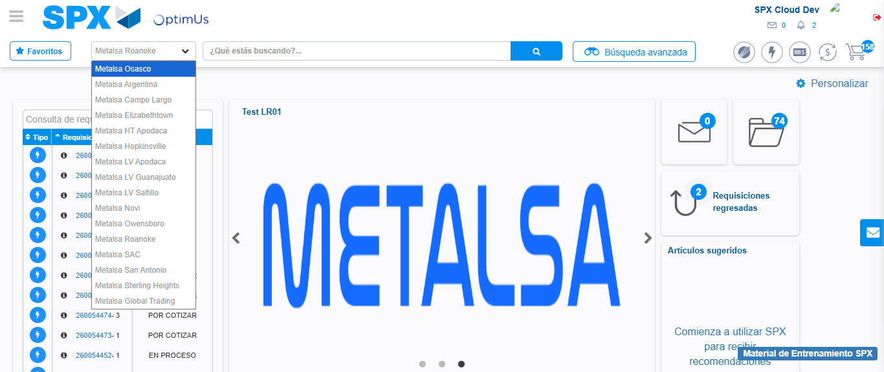Image file-name: QC_Testing-tc001_SPX_Dev5_Crear_Requisicion_Spot_Tipo_Cobro_CC-1782164078579

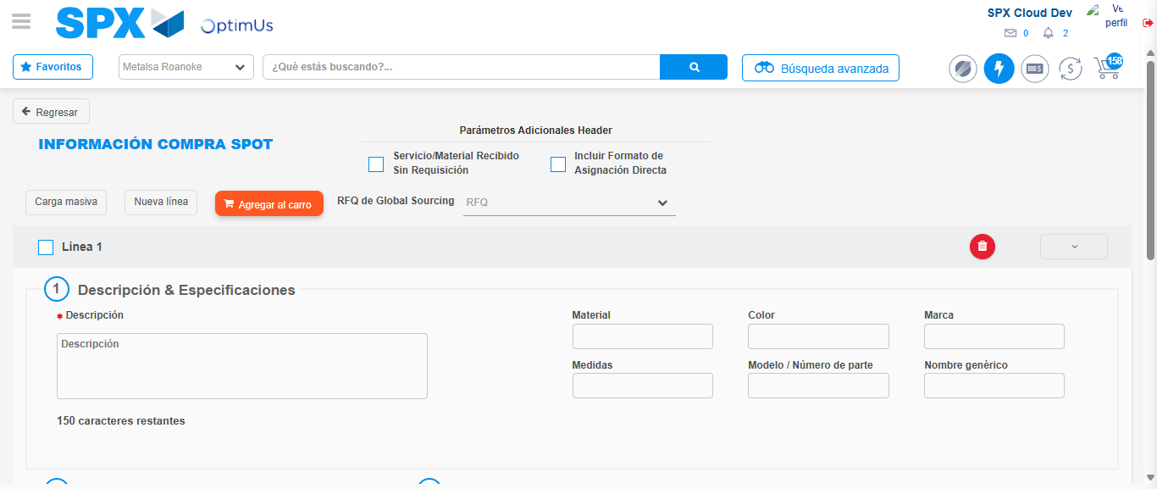Image file-name: QC_Testing-tc001_SPX_Dev5_Crear_Requisicion_Spot_Tipo_Cobro_CC-1782164116879

Step 3 - Data Capture Spot Buy Requisition : Data captured correctly
Image file-name: QC_Testing-tc001_SPX_Dev5_Crear_Requisicion_Spot_Tipo_Cobro_CC-1782164117099

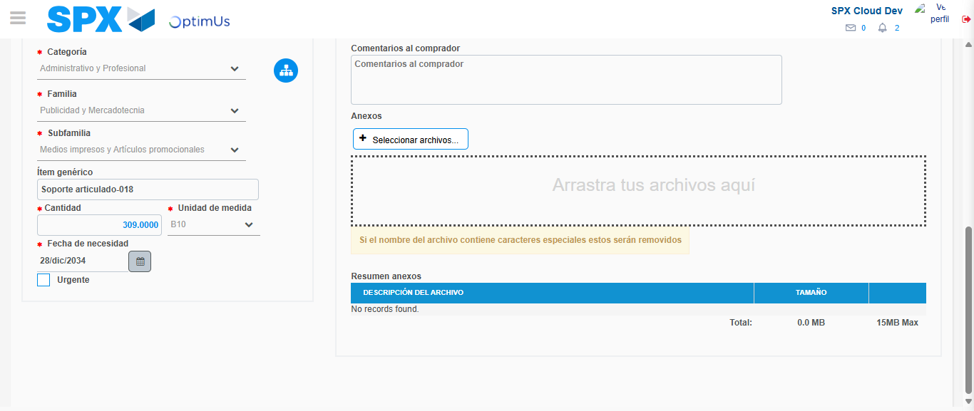Image file-name: QC_Testing-tc001_SPX_Dev5_Crear_Requisicion_Spot_Tipo_Cobro_CC-1782164129687

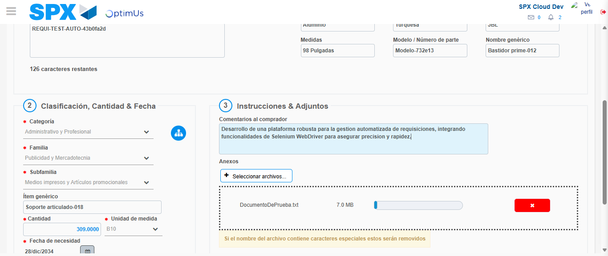Image file-name: QC_Testing-tc001_SPX_Dev5_Crear_Requisicion_Spot_Tipo_Cobro_CC-1782164130510

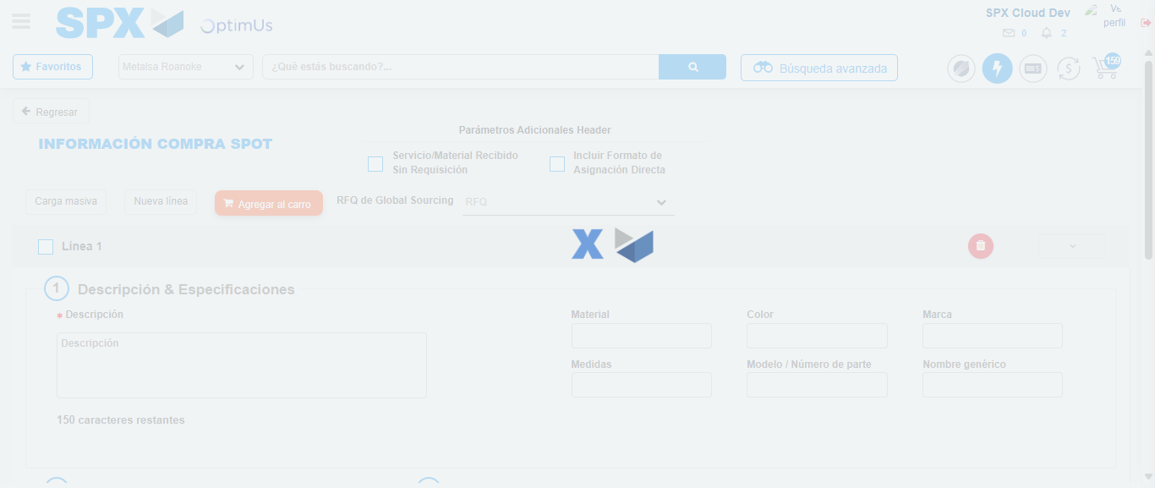Image file-name: QC_Testing-tc001_SPX_Dev5_Crear_Requisicion_Spot_Tipo_Cobro_CC-1782164135619

Step 4 - Select to Requisition : Requisition Correctly selected
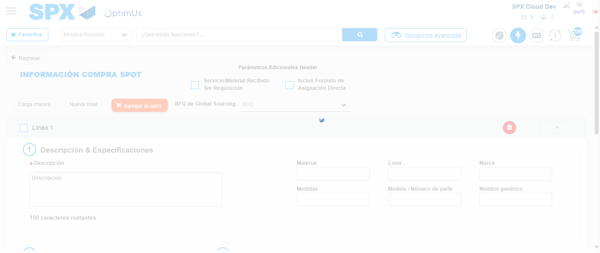Image file-name: QC_Testing-tc001_SPX_Dev5_Crear_Requisicion_Spot_Tipo_Cobro_CC-1782164135859

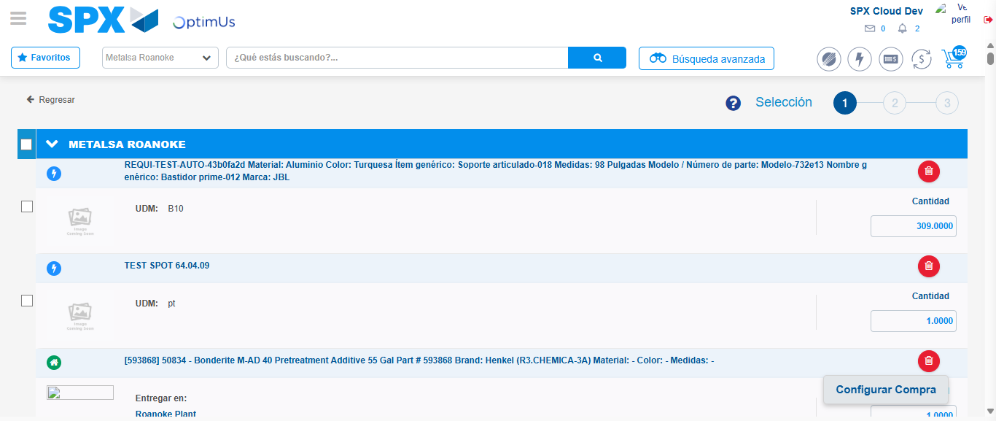Image file-name: QC_Testing-tc001_SPX_Dev5_Crear_Requisicion_Spot_Tipo_Cobro_CC-1782164150473

Image file-name: QC_Testing-tc001_SPX_Dev5_Crear_Requisicion_Spot_Tipo_Cobro_CC-1782164150690

Image file-name: QC_Testing-tc001_SPX_Dev5_Crear_Requisicion_Spot_Tipo_Cobro_CC-1782164150920

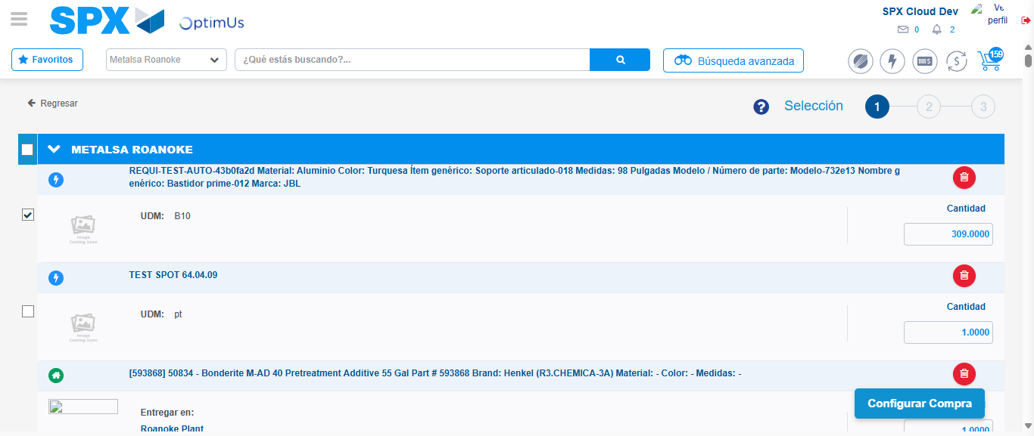Image file-name: QC_Testing-tc001_SPX_Dev5_Crear_Requisicion_Spot_Tipo_Cobro_CC-1782164152910

Step 5 - Select Type Account For Requisition : Type Account Correctly selected
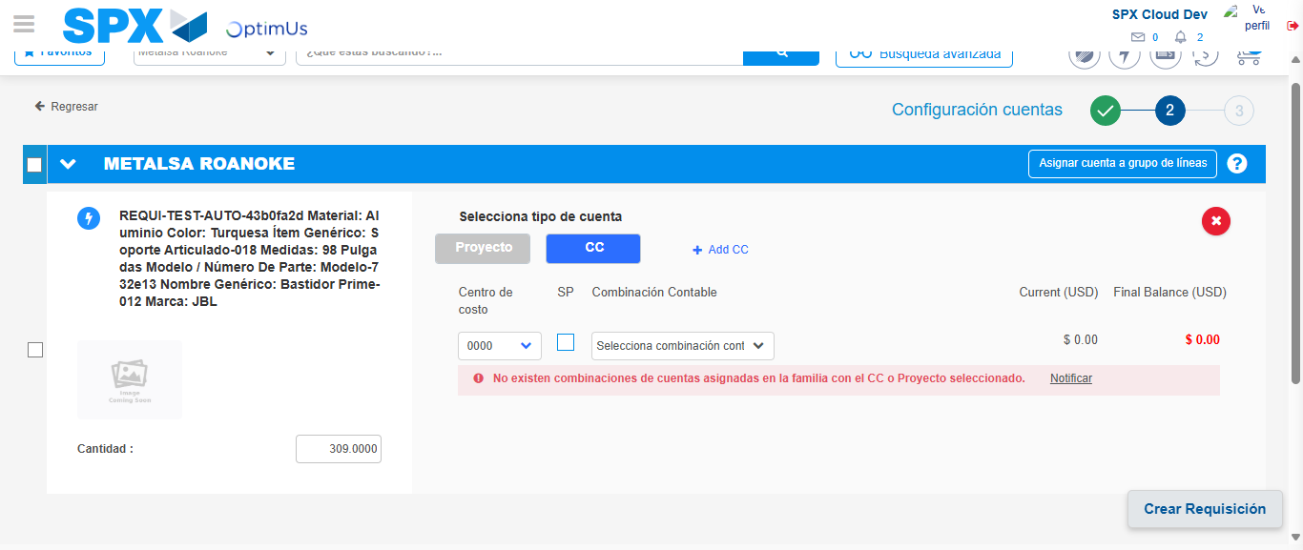Image file-name: QC_Testing-tc001_SPX_Dev5_Crear_Requisicion_Spot_Tipo_Cobro_CC-1782164174601

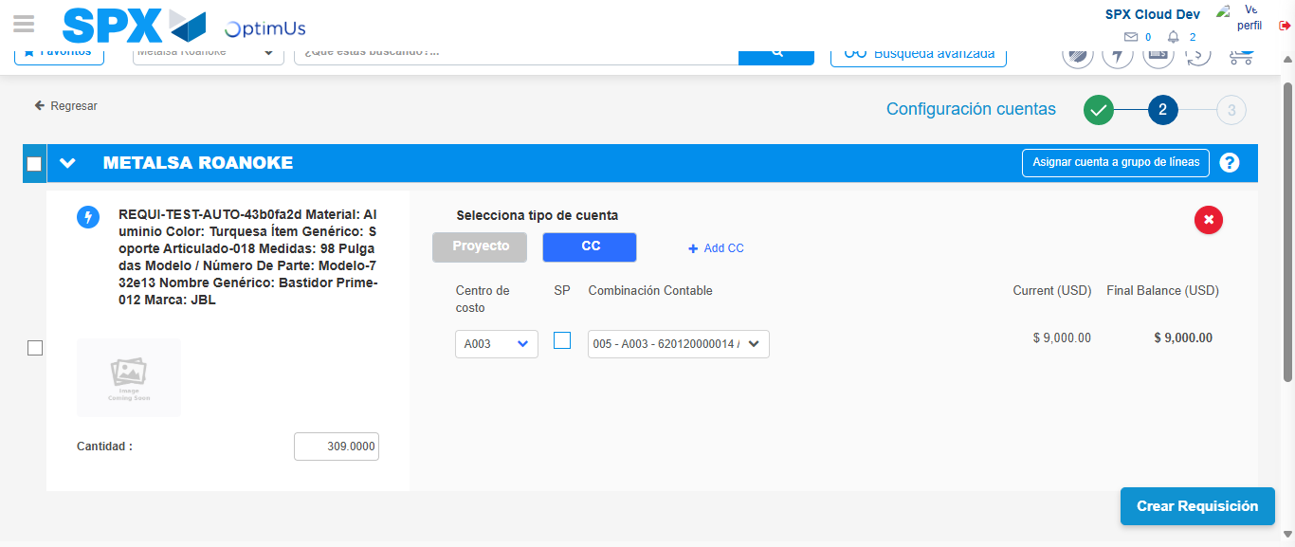Image file-name: QC_Testing-tc001_SPX_Dev5_Crear_Requisicion_Spot_Tipo_Cobro_CC-1782164180119

Image file-name: QC_Testing-tc001_SPX_Dev5_Crear_Requisicion_Spot_Tipo_Cobro_CC-1782164180306

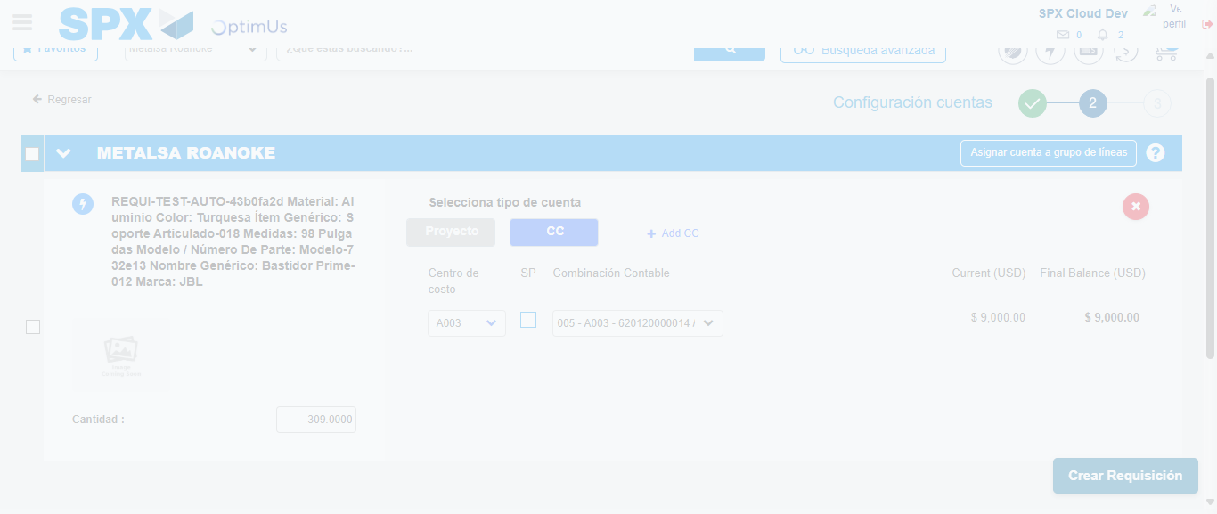Image file-name: QC_Testing-tc001_SPX_Dev5_Crear_Requisicion_Spot_Tipo_Cobro_CC-1782164180713

Step 6 - Accept to Requisition : Requisition Accepted
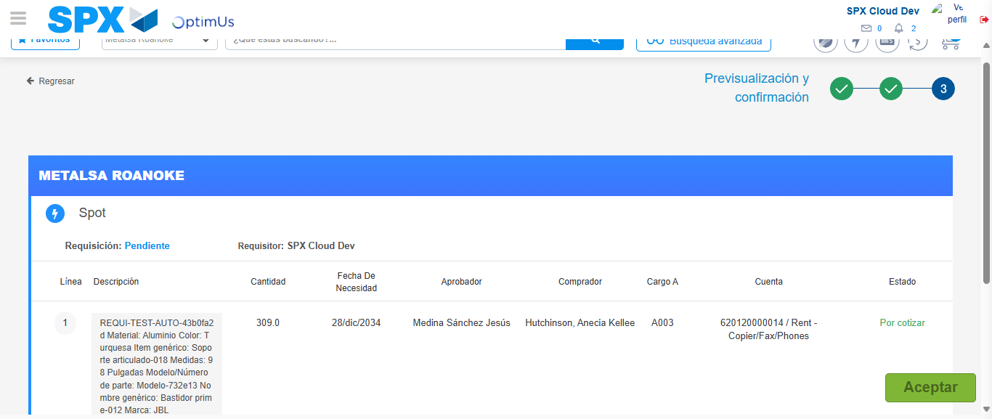Image file-name: QC_Testing-tc001_SPX_Dev5_Crear_Requisicion_Spot_Tipo_Cobro_CC-1782164182026

Image file-name: QC_Testing-tc001_SPX_Dev5_Crear_Requisicion_Spot_Tipo_Cobro_CC-1782164182225

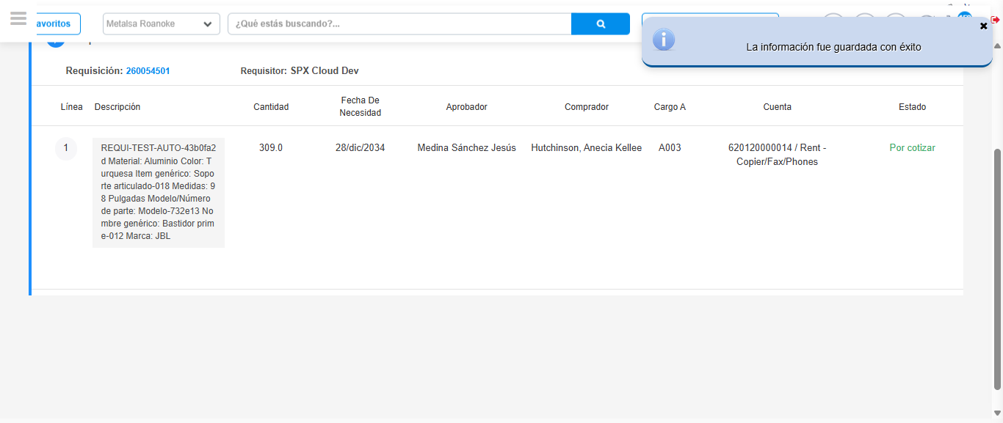Image file-name: QC_Testing-tc001_SPX_Dev5_Crear_Requisicion_Spot_Tipo_Cobro_CC-1782164186698

Step 7 - Return to Main Page SPX : Return to Main Page SPX
Image file-name: QC_Testing-tc001_SPX_Dev5_Crear_Requisicion_Spot_Tipo_Cobro_CC-1782164075975

Image file-name: QC_Testing-tc001_SPX_Dev5_Crear_Requisicion_Spot_Tipo_Cobro_CC-1782164078579

Image file-name: QC_Testing-tc001_SPX_Dev5_Crear_Requisicion_Spot_Tipo_Cobro_CC-1782164116879

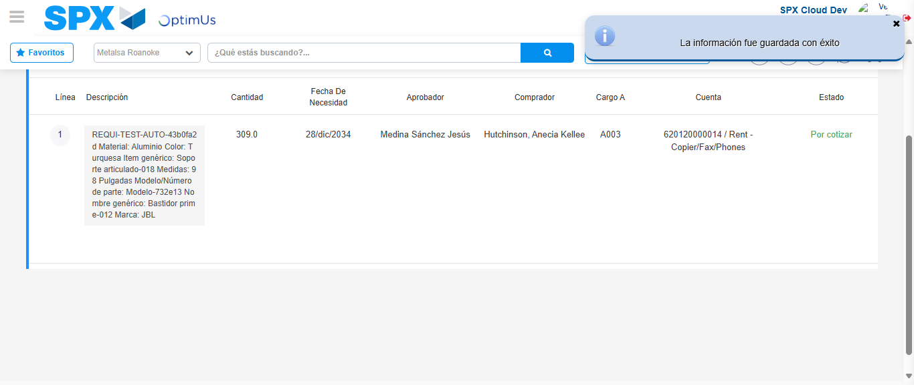Image file-name: QC_Testing-tc001_SPX_Dev5_Crear_Requisicion_Spot_Tipo_Cobro_CC-1782164188920

Image file-name: QC_Testing-tc001_SPX_Dev5_Crear_Requisicion_Spot_Tipo_Cobro_CC-1782164189092

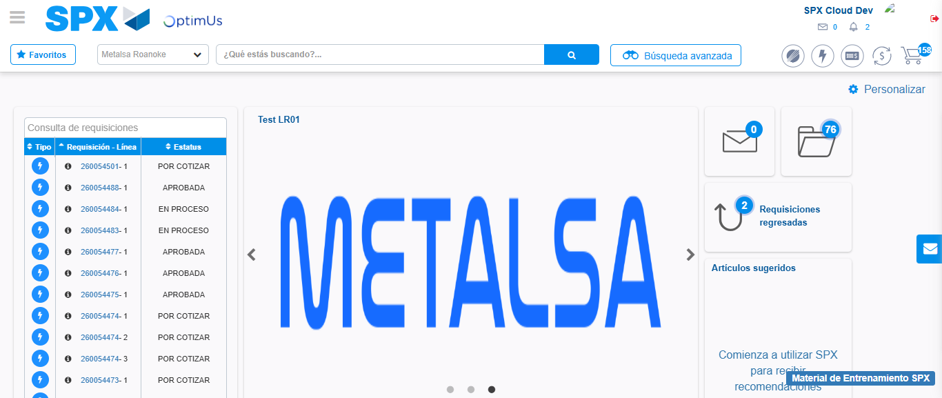Image file-name: QC_Testing-tc001_SPX_Dev5_Crear_Requisicion_Spot_Tipo_Cobro_CC-1782164210206

Step 8 - Log Out : Log Out SPX
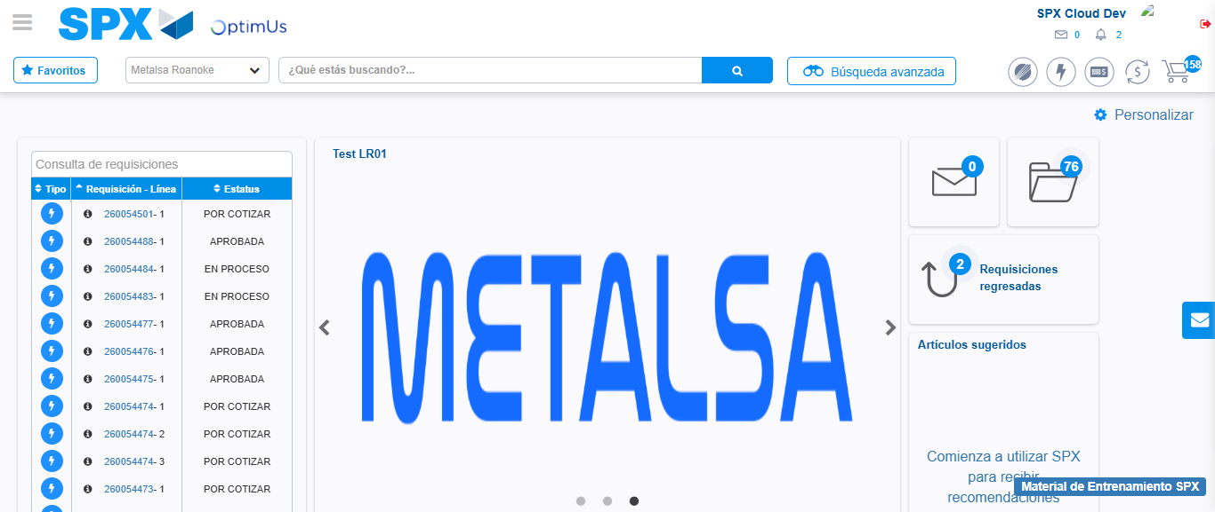Image file-name: QC_Testing-tc001_SPX_Dev5_Crear_Requisicion_Spot_Tipo_Cobro_CC-1782164210496

